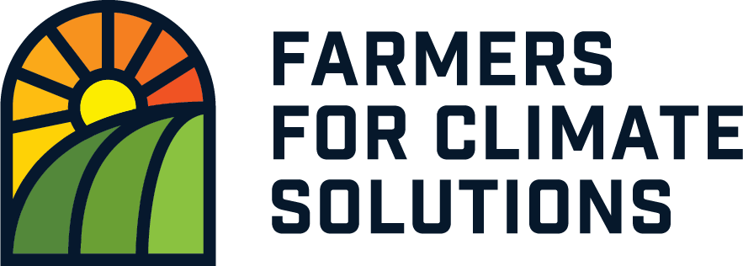
Welcome to the Farm Resilience Mentorship (FaRM) program!
Farmers for Climate Solutions(FCS) is a non-commercial entity committed to the lawful, fair, and transparent collection, use and protection of personal data. This notice is intended to help you understand how we collect and use your personal data, as well as how we share, store, and protect that data.

Terms of Use and Privacy of Information Statement
Definitions:
Personal information refers to any information that can be used to identify you, including Name, phone number and email address.

Special categories of personal information includes personal data revealing information such as racial or ethnic origin, age, gender or sexual orientation.

Demographic information includes language preference, land size, province of operation

Personal information does not include information that you voluntarily disclose or documents you voluntarily share with online community groups you may choose to join as part of your course, or any contact or other information that is generally visible through public resources.

What data we collect about you
We collect your personal data when you voluntarily provide it to us. For example, you may give us: your email address, your contact information, and any other personal data you choose to include, if you email, text, or instant message us, or contact us through our sites; and any personal data contained in, or included with, any documents, feedback, comments, photos, videos, or other information you voluntarily disclose or submit via online portals, forms, surveys, or interactive portions of our sites.

When data is collected
Information may be directly collected during:
- Course registration to the FaRM program,
- Classroom virtual meetings
- Post-course and follow up surveys,
- Through user analytics on the Learning Management System (LMS).
The LMS is the software package that facilitates the delivery of online learning. Functionalities include: presentation of course curriculum, library of course reading materials, virtual meeting spaces, discussion boards/chat rooms, games/interactive content, tests/assessments, course and instructor evaluations/surveys, push notifications and email calendar invites.

Why we collect this data
Data is collected in order to:
- assess the effectiveness of the FaRM program at meeting its goals and increasing adoption of beneficial management practices;
- identify and remove barriers to participation in the FaRM program and implementation of skills learned;
- increase political and public support for farmers through policy advocacy, education and communications.

How we use your data
Registration data will be used to determine optimal placement in courses given geographical, operational and demographic considerations.
Data collected in the online LMS will be used to improve the services and course content we provide you with and to assess course progression, completion rates, and to provide email calendar invitations to live course events, webinars and community chat rooms.
Data collected during registration, in pre and post course surveys, follow up surveys, interviews or focus groups will be used to assess the course content, mentor skills and knowledge and to determine effectiveness of the FaRM program at increasing adoption of climate-friendly farming practices across Canada.
Data used for reporting purposes will be anonymized (i.e., contains no personal information) and aggregated (combined into a single group or total) in order to see trends in knowledge gain, retention and implementation of climate-friendly farming practices across various demographics and special categories as necessary to accomplish our goals or validate scientific findings. Specifically, we may share anonymized data at some point in the future with other researchers for non-commercial academic research purposes and to the public to influence Federal and Provincial policy.

How we share your data
We limit access to personal data and require that employees and third party service providers authorized to access personal data are contractually obligated to maintain confidentiality indefinitely.
As a first precaution, we will make reasonable efforts to limit the number of people with access to your personal information. We may share your personal data with our employees and our service providers (including consultants, contractors, and out-sourced service providers) to process it for us based on our instructions and for no other purpose. We do not share your personal data with any third party (including our service providers) for marketing purposes.
The only circumstance under which personal information may be disclosed to contracted third parties is for the fulfillment of any purposes identified above, or as required or permitted by law.
We will not use or disclose personal information for any additional purpose unless we obtain consent to do so, and we do not sell, trade, or rent information to third parties.
It is always your choice whether to provide this personal data. However, some personal data must be provided to participate in certain programs, activities, or events (such as to attend online and in person classes, or register to participate in one of our courses), so the decision not to provide information might limit or eliminate your ability to participate in such programs, activities, or events.

Where do we store your data?

Our LMS application is hosted on Growth Engineering web servers. Growth Engineering is EU General Data Protection Regulation (GDPR) compliant and audited as per ISO 27001 and ISO 9001 . For more details, read Growth Engineering’s privacy policy.

As the transmission of data via the internet is not completely secure, we cannot guarantee the security of your information transmitted to our sites and any such transmission is at your own risk. However, we maintain appropriate technical and organizational measures, to prevent unauthorized disclosure of, or access to, personal data.
Please note that we are not responsible for any of the content, features, functionality, or privacy practices of other websites linked to or accessible from our sites. The data collection and use practices of any linked third-party site will be governed by that third party’s applicable privacy notice, statement, or policy, and its terms of use. We encourage you to read them.

How long will we retain your data?

We aim to retain your data indefinitely in the interests of scientific reproducibility, but for a minimum of 5 years.

Who funds FCS?

The FaRM program is currently funded by anonymous private philanthropic grants. Our funders have no say in the operation and management of the FaRM program, and are unable to access any of the personal information housed on the platform. Our funding model is currently donor and grant-driven. Seed Change is the secretariat for FCS. You can read their privacy policy here.

What are your rights with respect to your personal information?

Your participation in the FaRM program is entirely voluntary. You may choose to inactivate your LMS account at any time without giving a reason.

You have the right to know what data we have about you, request a copy of it, update and correct your data, request that we stop collecting your data, ask questions about any analyses using your data and withdraw any consent you previously provided to us.

If at any time you have questions about this statement, if you believe personal data you provided to us is being misused by a third party, if you wish to learn more about your data uses, or would like to withdraw consent, please contact admin@farmersforclimatesolutions.ca

